1.

(a) Noted that column 1 is strictly dominated by column 3. Then, in the residual game bimatrix, row 1 and row 4 are both strictly dominated by row 2. Next, column 2 is strictly dominated by column 4. We are now left with the following residual game:

(7,5) (7,9)

(8,5) (5,4)

We use the corollary to Nash’s theorem to compute the unique NE in the residual game as follows: Suppose player 1 plays strategy 1 with probability p1 and strategy 2 with probability p2, where p1+p2 = 1, 0 < p1, p2< 1. Suppose player 2 plays strategy 1 with probability q1 and strategy 2 with probability q2, where q1+q2 = 1, 0 < q1, q2< 1.

Using the corollary of the Nash theorem, if player 2 is playing against player 1’s mixed strategy, both of player 2’s pure strategies must be a best response to player 1. The same argument applies for player 1.

7*q1+7*q2 = 8*q1+5*q2

q1+q2=1

5*p1+5*p2 = 9*p1+4*p2

p1+p2=1

By doing the arithmetic, we find p1 = 1/5, p2=4/5, q1=2/3, q2=1/3.

Therefore, a NE for this game is**: [(0,1/5, 4/5, 0), (0, 0, 2/3, 1/3)].** The expected payoff for player 1 under this strategy profile is 7, whereas the expected payoff for player 2 is 5.

**[2,4] [3,3] [4,1]**

Due to the claim of NE that

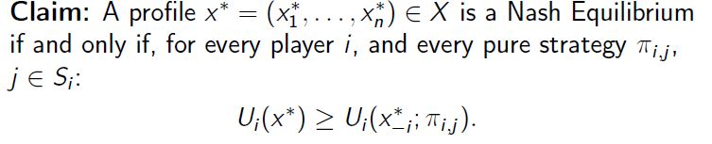

For player 1, the payoffs of its four pure strategy given fixed player 2’s strategy are 20/3, 7, 7, 3, which are smaller or equal to player 1’s expected payoff 7. Likewise, for player 2, the payoffs of its four pure strategy given fixed player 1’s strategy are 4/5, 22/5, 5, 5, which are smaller or equal to player 2’s expected payoff 5. Thus, [(0,1/5, 4/5, 0), (0, 0, 2/3, 1/3)] is indeed an NE of G.

A strategy that is strictly dominated cannot be played with non-zero probability in any NE, and therefore we don’t eliminate NE’s by eliminating strictly dominated strategies. During the arithmetic process, p1, p2, q1, and q2 are both uniquely determined so it must imply that there is only one NE in this game.

(b)

2.

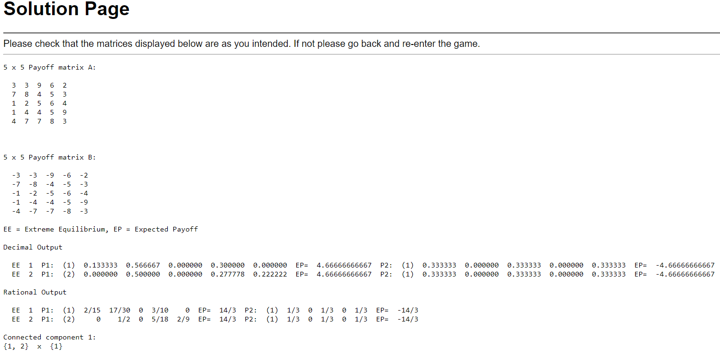

(a)

EE 1 P1: (1) 2/15 17/30 0 3/10 0 EP= 14/3 P2: (1) 1/3 0 1/3 0 1/3 EP= -14/3

EE 2 P1: (2) 0 1/2 0 5/18 2/9 EP= 14/3 P2: (1) 1/3 0 1/3 0 1/3 EP= -14/3

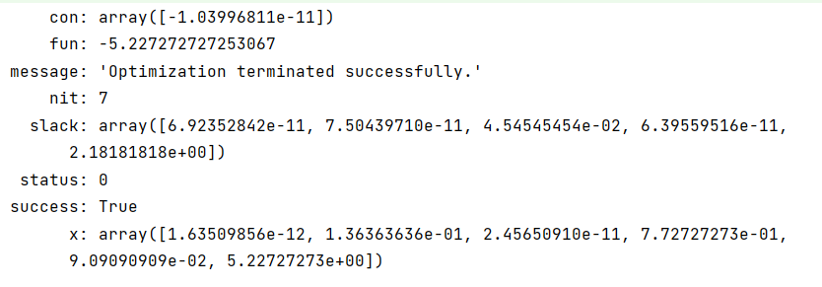

(b)

Because game G is a symmetric 2- player zero-sum game, the payoffs of both player under every minmaximizer strategy is 0, i.e., C^Tx = b^Ty=0. Every minmaximizer strategy is a NE in symmetric 2- player zero-sum game. The pure strategy with non-zero probability in the each player’s minmaximizer strategy could also have the payoff 0. Through observation of skew-symmetric payoff matrix, we found that the last pure strategy will always gain 0 payoff when player’s strategy from the minmaximizer profile. For other two pure strategies, given that there exist vectors x 0 ∈ R n and y 0 ∈ R m, such that Ax’ < b, x’ ≥ 0, AT y’ > c and y’ ≥ 0, with the constrains of LP in minimax, we can tell that only x>0 can we get Ax’ <= bz, ATy’>=c z. Therefore, it’s reasonable that every minmaximizer strategy w = (y ∗ , x∗ , z) for player 1 has the property that z > 0.

Let w = (y ∗ , x∗ , z) be a maxminimizer strategy for player 2 in the game G. Note that the value of any symmetric 2-player zero-sum game must be equal to zero. This implies, by the minimax theorem, that Bw ≤ 0. If z=0, Ax* <=0, -ATy*<=0,

3.

(a)

[(0.5, 0.5), (0.5, 0.5)] v= 0

(b)

(3, 6) (3, 7) (7, 8) (6, 7)

(4, 4) (4, 6) (7, 5) (7, 9)

(4, 0) (5, 4) (8, 5) (5, 4)

(4, 3) (1, 2) (4, 3) (1, 3)